**A Project Report**

**On**

**“Project Name”**

Submitted in partial fulfillment of the

**BACHELOR OF COMPUTER APPLICATION**

**By**

**“Student Name”**

**Enrollment No.**

**Under the esteemed guidance of**

**Guide Name**

**Guide Designation**

**&**

**“Dr. Arvind Kumar Pandey”**

**Dean**

**School of Engineering and IT**



**DEPARTMENT OF COMPUTER SCIENCE & IT**

**ARKA JAIN UNIVERSITY, JHARKHAND**

**2022-2025**

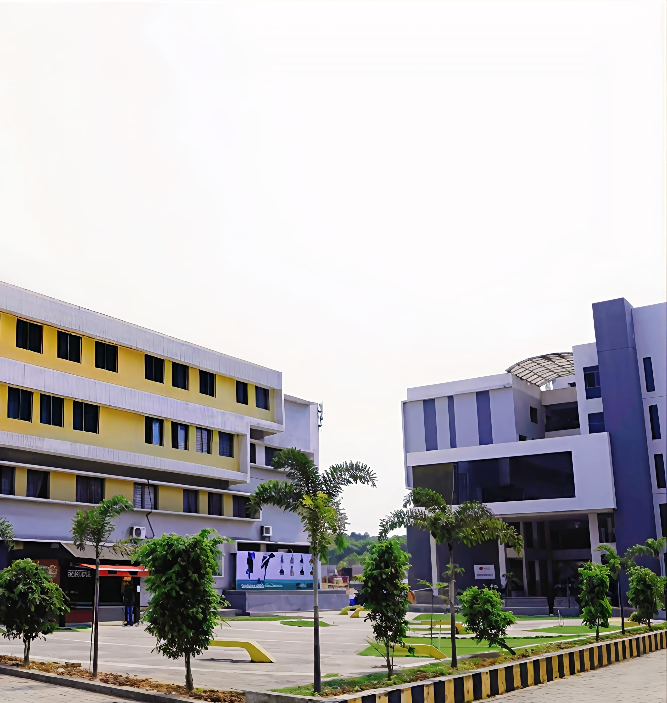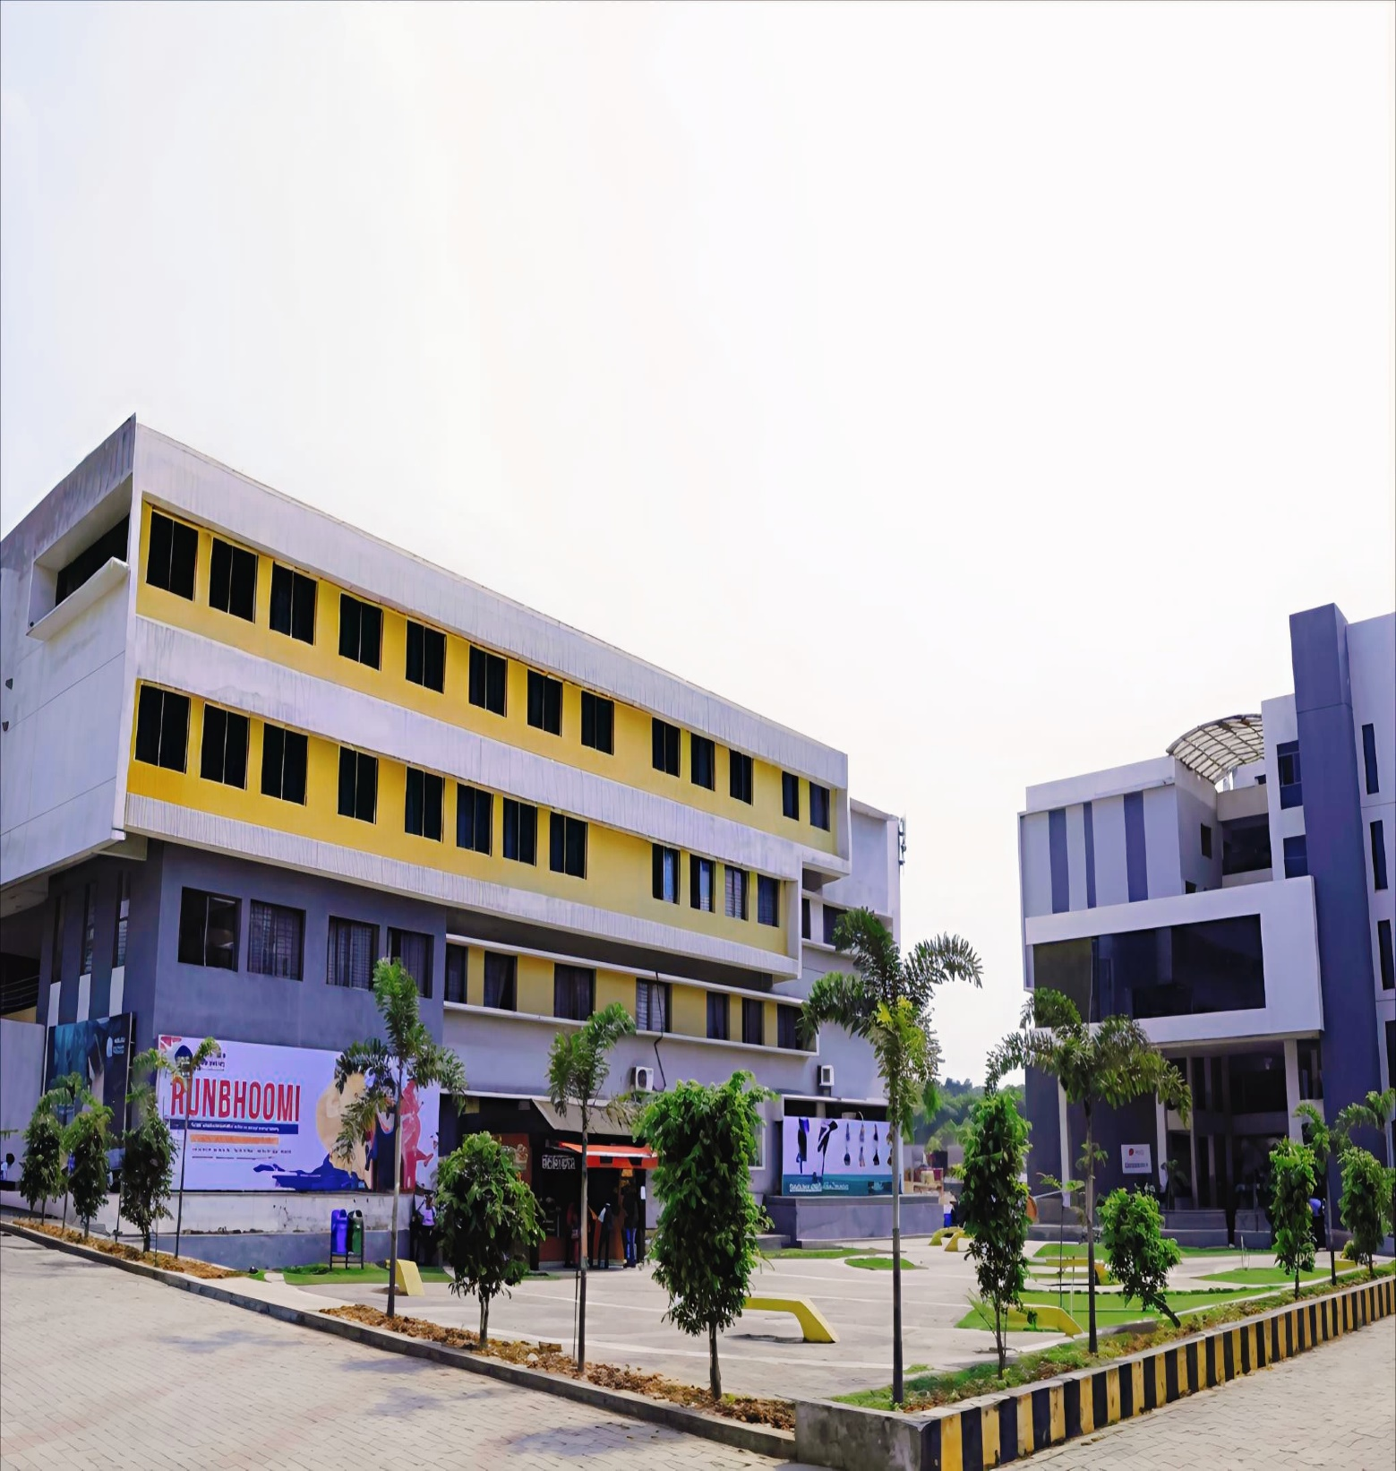

**A PROJECT REPORT ON**

**“PROJECT NAME”**

**IN PARTIAL FULFILLMENT OF REQUIREMENT**

**OF**

**BACHELOR OF COMPUTER APPLICATION**

**BATCH 2022-2025**

**UNDER THE GUIDANCE OF: PREPARED BY:**

**DR. ARVIND KUMAR PANDEY Student Name**

**DEAN**

**SCHOOL OF ENGINEERING AND IT**

**SUBMITTED TO**

**DEPARTMENT OF COMPUTER SCIENCE & IT ARKA JAIN UNIVERSITY, JHARKHAND**



**CERTIFICATE**

This is to certify that the project entitled, **"Project Name"**, is bonafide work of **Student Name** bearing Enrollment No **AJU/XXXXX** under the guidance of Dean, School of Engineering and IT, **Dr. Arvind Kumar Pandey** submitted in partial fulfillment of the requirements for the award of degree of BACHELOR OF COMPUTER APPLICATION from ARKA JAIN UNIVERSITY, JHARKHAND during the academic year 2024-2025.

Internal Guide Dr. Arvind Kumar Pandey

Dean

School of Engineering & IT ARKA JAIN UNIVERSITY, Jharkhand

Date: University Seal

II

**COMPANY INTERNSHIP CERTIFICATE**

III



**ABSTRACT**

An abstract is a short and powerful summary that describes the focus of a project. It is originally written content—not an excerpt from the larger work—and usually contains keywords that are found throughout the full project itself.

IV



**ACKNOWLEDGEMENT**

After completion of my final year project, I would like to take this chance to express my sincere gratitude to my project guide and Dean, School of Engineering and IT, **Dr. Arvind Kumar Pandey** who has guided me a lot throughout my project development. Without him, I think I could not have finished the project on time. In addition, while I met some logic problem or design problem, he was always the one who gave me useful and logical answers.

I would like to thank **Guide Name** for one more time for sharing his experience with me so that I could get more logical understanding on how to develop chat application which is suitable for current society.

Finally, I want to thank to all my friends and teachers, who helped and co-operated with me directly or indirectly in the accomplishment of this project.

.

V



**DECLARATION**

I STUDENT NAME hereby declare that the project entitled, “PROJECT NAME” done at ARKA JAIN UNIVERSITY, has not been in any case duplicated to submit to any other university for the award of any degree. To the best of my knowledge other than me, no one has submitted to any other university.

The project is done in partial fulfillment of the requirements for the award of degree of BACHLEOR OF COMPUTER APPLICATION to be submitted as final semester project as part of our curriculum.

**STUDENT NAME**

**AJU/XXXXXX**

VI

**TABLE OF CONTENTS**

**Chapter 1**

**Introduction...............................................................................................................9**

1.1 Overview .......................................................................................................XX

1.2 Objectives and Features ................................................................................XX

**Chapter 2**

**Requirement and Analysis ......................................................................................10-XX**

2.1 Software Requirement Specification.............................................................XX

2.2 Data Gathering.............................................................................................. XX

2.3 Feasibility Study............................................................................................XX

2.4 Hardware Requirements…………………………………………………….XX

2.5 Software Requirements……………………………………………………..XX

2.6Justification of Selection of Technology .......................................................XX

2.7 Use Case Diagram……………………………………………………….….XX

2.8 Data Flow Diagram (DFD) ...........................................................................XX

2.8.1 DFD Level 0....................................................................................XX

2.8.2 DFD Level 1....................................................................................XX

2.8.3 DFD Level 2....................................................................................XX

**Chapter 3**

**System Design................................................................................................................ 11**

3.1 Entity Relationship Diagram (ER- Diagram)................................................ XX

3.2 Data Normalization....................................................................................... XX

3.3 Data Dictionary............................................................................................. XX

**Chapter 4**

**Program Code and Testing......................................................................................... 12**

4.1 Coding........................................................................................................ XX

4.2 Testing Approach....................................................................................... XX

**Chapter 5**

**Results and Discussion............................................................................................... 13**

5.1 Output Screen............................................................................................. XX

5.2 Limitation................................................................................................... XX

5.3 Future Scope............................................................................................... XX

**Chapter 6**

**Conclusion................................................................................................................... 14**

**Chapter 7**

**References................................................................................................................... 15**

**Chapter 1**

**INTRODUCTION**

**1.1 OVERVIEW**

**1.2 OBJECTIVE**

9

**Chapter 2**

**REQUIREMENTS AND ANALYSIS**

**2.1 Software Requirement Specification**

**2.2 Data Gathering**

**2.3 Feasibility Study**

**2.4 Hardware Requirements**

**2.5 Software Requirements**

**2.6 Justification of Selection of Technology**

**2.6.1 (USER INTERFACE)**

**2.6.2 (SERVER-SIDE LOGIC)**

**2.6.3 (DATABASE)**

**2.7 Use Case Diagram**

**2.8 Data Flow Diagram (DFD)**

**2.8.1 Context level DFD – 0 level**

**2.8.2 DFD level 1**

**2.8.3 DFD level 2**

10

**Chapter 3**

**SYSTEM DESIGN**

**3.1 ER DIAGRAM**

**3.2 DATA NORMALIZATION**

**3.3 DATA DICTIONARY**

11

**Chapter 4**

**PROGRAM CODE AND TESTING**

**4.1 CODING**

**4.2 TESTING APPROACH**

12

**Chapter 5**

**RESULTS AND DISCUSSION**

**5.1 OUTPUT SCREENS**

**5.2 LIMITATION**

**5.3 FUTURE SCOPE**

13

**Chapter 6**

**CONCLUSION**

14

**Chapter 7**

**REFERENCES**

15